[INTEGRATING SENDGRID SERVICE](https://careereducation.smartinternz.com/Student/guided_project_workspace/24165)

|  |  |
| --- | --- |
| Date | 01 November 2022 |
| Team ID | PNT2022TMID51918 |
| Project Name | Project - Personal Expense Tracker Application |

# SendGrid Integration With Python Code

To send emails from the application we need to integrate the SendGrid Service. Please reference link.

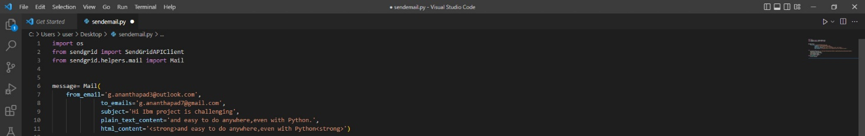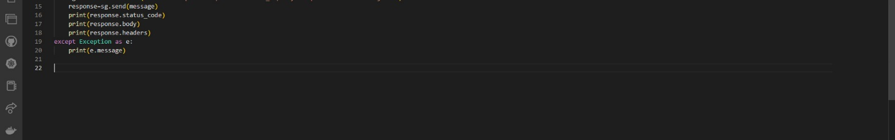

**Code:**

import os

from sendgrid import SendGridAPIClient

from sendgrid.helpers.mail import Mail

message= Mail(

    from_email='g.ananthapad3@outlook.com',

              to_emails='g.ananthapad7@gmail.com',

              subject='Hi Ibm project is challenging',

              plain_text_content='and easy to do anywhere,even with Python.',

              html_content='<strong>and easy to do anywhere,even with Python<strong>')

try:

sg = sendgrid.SendGridAPIClient(api_key=os.environ.get('SENDGRID_API_KEY'))

 response=sg.send(message)

    print(response.status_code)

    print(response.body)

    print(response.headers)

except Exception as e:

    print(e.message)

sg = sendgrid.SendGridAPIClient(api_key=os.environ.get('SENDGRID_API_KEY'))

